DEPARTMENT OF

ELECTRONICS AND COMMUNICATION ENGINEERING PUDUCHERRY TECHNOLOGICAL UNIVERSITY
PUDUCHERRY – 605 014

BONAFIDE CERTIFICATE
This is to certify that this project report titled, “NATURAL LANGUAGE PROCESSING AND REINFORCEMENT DEEP LEARNING FOR FAKE MEDIA DETECTION USING BLOCKCHAIN” is the bonafide work done by Jeswanth P.G [20EC1067], Singupuram Shanmukha Rao [20EC1102], Sri Saipriya R[20EC1109], Yeguru Deepak Prasad[20EC1122] in the partial fulfilment of the requirement for the award of the degree of BACHELOR OF TECHNOLOGY in ELECTRONICS AND COMMUNICATION ENGINEERING during the year 2023-2024 in PUDUCHERRY TECHNOLOGICAL UNIVERSITY and this work have not been submitted for the award of any other degree of this/any other university.

PROJECT GUIDE HEAD OF THE DEPARTMEN (DR. V. VIJAYALAKSHMI) (Dr. V. SAMINADAN)

Submitted for the University Examination held on .

INTERNAL EXAMINER EXTERNAL EXAMINER

ACKNOWLEDGEMENT
The successful completion of the project is indeed practically incomplete without the mention of all those people who greatly supported and encouraged us throughout the project. We feel grateful to our guide DR. V. VIJAYALAKSHMI, Professor, Department of Electronics and Communication Engineering, Puducherry Technological University, for her encouragement and support. He has been a source of valuable guidance, suggestions and kindness during the course of project work.

We would like to express our sincere thanks to our Respected VICE CHANCELLOR Dr.
S. MOHAN, Puducherry Technological University for providing the University facilities for the completion of this project.

We would like to express our heartfelt gratitude to Dr. V. SAMINADAN, Professor and Head, Department of Electronics and Communication Engineering, Puducherry Technological University for providing all department facilities and guidance which enabled us to complete the project.

We feel obliged to thank the main project panel members Dr. GNANOU FLORENCE SUDHA, Professor, Dr. K. JAYANTHI, Professor, Dr. K. KUMAR, Professor, Dept. of Electronics and Communication Engineering, PTU for the support, encouragement and guidance.

We express our deep sense of gratitude to all teaching and non-teaching staff of our department, and to our friends for their support and encouragement during the entire course of this main project work. We also express our sincere thanks to our parents who motivated us in all means.

ABSTRACT

Based on recent developments in computer science, social media networks have become integral to human life, serving as platforms for sharing information, news, and daily updates. However, fake news and misleading information have become significant problems in this environment. To address this issue, we propose an integrated system that combines blockchain technology, natural language processing (NLP), and reinforcement learning.

Natural language processing (NLP) is crucial for understanding and analyzing textual content shared on social media platforms. Techniques such as sentiment analysis and language understanding help identify patterns indicative of misleading content.

Blockchain technology offers a decentralized and immutable ledger for verifying the authenticity of information and transactions. By leveraging blockchain, our system creates a secure platform for verifying the credibility of news sources and the integrity of shared information.

Reinforcement learning continuously improves the fake news detection model by learning from user feedback and interactions. This helps optimize decision-making processes and mitigate the spread of misinformation. In addition to detecting fake news articles, our system focuses on identifying fake user accounts and posts by analyzing behavior and content. By flagging suspicious accounts and content, we can protect users from being misled.

Overall, the proposed system aims to create a secure and trustworthy platform for predicting and identifying fake news in social media networks. By integrating NLP, blockchain, and reinforcement learning techniques, we provide a comprehensive solution to combat the spread of misinformation.

CONTENT SHEET

CHAPTER NO. |  | TITLE | PAGE NO.
 |  | BONAFIDE CERTIFICATE | ii
 |  | ACKNOWLEDGEMENT | iii
 |  | ABSTRACT | iv
 |  | LIST OF FIGURES | viii
 |  | LIST OF TABLES | ix
 |  | LIST OF ABBREVATIONS | x
1 |  | INTRODUCTION | 1
 |  | 1.1 Prelude | 1
 |  | 1.2 Motivation | 2
 |  | 1.3 Literature Review | 3
 |  | 1.4 Objective | 6
 |  | 1.5 System Model | 6
 |  | 1.6 Organization of Thesis | 8
2 |  | EXISTING WORK | 9
 |  | 2.1 Methodology | 9
 |  | 2.2 Data Gathering and Pre-processing  2.2.1. Data cleaning  2.2.2. Data Stemming  2.3. Support Vector Machine (SVM) Classification  2.3.1. About SVM  2.3.2. Strengths  2.3.3. Key concepts  2.4. Limitations  2.5. Disadvantages | 9  9  9  9  10  10  10  11  11
3 |  | PROPOSED SYSTEM | 12
 |  | 3.1 Methodology | 12
 |  | - Data Preprocessing  3.2.1. Natural Language Processing  3.3 Reinforcement Learning  3.4. Random Forest  3.5. Blockchain  3.6. Combined Approach | 12  12  13  14  15  16
4 |  | HARDWARE & SOFTWARE REQUIREMENTS  4.1. Hardware Requirements  4.2. Software Requirements  4.3. Frameworks  4.4. Modules | 17  17  17  17  18
 | 5 | RESULTS & DISCUSSIONS |  | 21
 |  | 5.1 Numerical Methods to calculate errors |  | 21
 |  | 5.2 Screenshots |  | 23
 | 6 | CONCLUSION & FUTURE SCOPE |  | 30
 |  | 6.1 Conclusion |  | 30
 |  | 6.2 Future Scope |  | 31
 |  | REFERENCES |  | 32

LIST OF FIGURES

FIGURE NO. | TITLE | PAGE NO.
1.1 | System Model | 6
3.1 | Reinforcement Learning | 13
3.2 | Decision Tree Diagram | 15
5.2.1 | New user Sign up | 23
5.2.2 | Sign up Details | 24
5.2.3 | Succeed of Sign up | 24
5.2.4 | User Login | 25
5.2.5 | Welcome Screen | 25
5.2.6 | Fake & Real news graph | 26
5.2.7 | Load Dataset | 26
5.2.8 | RMSE & MAE | 27
5.2.9 – 5.2.12 | Output | 28, 29

LIST OF TABLES

TABLE NO. | TITLE | PAGE NO.
1.1 | Literature Review | 3

LIST OF ABBREVIATION

NLP | Natural Language Processing
RL | Reinforcement Learning
NLTK | Natural Language Tool Kit
STO | Sea Turtle Foraging Optimization
RMSE | Root Mean Square Error
MAE | Mean Absolute Error
SVM | Support Vector Machine
RBF | Radial Basis Function
DQN  DRY  SVR  MVC  ORM | Deep Queue Network  Don’t Repeat Yourself  Support Vector Regression  Model-View-Controller  Object Relational Mapping

CHAPTER 1

INTRODUCTION

PRELUDE:
In today's digital age, social media networks have become integral to how we communicate, share information, and stay updated on current events. However, alongside the benefits of instant connectivity, the rampant spread of fake news and misinformation poses a significant challenge. The abundance of misleading information not only undermines the credibility of news sources but also threatens to mislead and manipulate users. In response to this pressing issue, we propose an integrated system that leverages cutting-edge technologies to detect and combat fake news in social media networks.
This project aims to address this problem by combining the power of blockchain technology, natural language processing (NLP), and reinforcement learning. By integrating these technologies, we seek to create a robust and secure platform capable of identifying fake news articles, predicting fake user accounts and posts, and ultimately fostering a more trustworthy social media environment.
Natural Language Processing (NLP) techniques allows for the identification of subtle forms of misinformation that may evade simple keyword analysis. By examining linguistic features, our system can identify suspicious user accounts and posts involved in spreading fake news or misinformation. Furthermore, the semantic understanding of NLP enables the classification of news articles based on their credibility and relevance, providing a more accurate and comprehensive solution to the growing problem of fake news. NLP is a powerful tool that plays a critical role in helping our system effectively analyze, understand, and combat fake news in social media networks.
Reinforcement Learning (RL) is being applied to tackle the proliferation of fake news on social media platforms. RL's capacity to continuously evolve and enhance its detection methodologies, optimize decision-making, and strike a balance between exploration and exploitation is vital for efficiently identifying false information. It's also heartening to learn that the system can utilize user feedback to fine-tune its capabilities over time. The dynamic and adaptable nature of RL ensures that the system remains effective in detecting and combatting the spread of misinformation on social media networks.

Blockchain technology is indeed a revolutionary innovation that has the potential to transform the way we store and manage data. It offers a secure, transparent, and immutable way of recording transactions and information, which is crucial in today's digital age where trust and transparency are critical. The decentralized nature of blockchain ensures that there is no central point of control, making it difficult for malicious actors to manipulate or corrupt the data. In the context of detecting and combating fake news on social media networks, blockchain technology can play a vital role in ensuring the authenticity of news sources and information. By providing a tamper-resistant framework for verifying the integrity of shared information, blockchain technology can enhance the credibility of the platform and make it more resistant to tampering and censorship.

MOTIVATION:
It's concerning to see how much counterfeit news and misinformation are spread on social media networks these days. Such platforms have become the go-to sources of information for millions of users worldwide, but they're also prone to the spread of deceptive content that can manipulate public opinion, undermine trust in institutions, and even incite violence. The consequences of misinformation can be severe, impacting political discourse, public health, and social cohesion. Hence, it's crucial to have effective solutions to combat counterfeit news and ensure the integrity of information shared on these platforms.
This project aims to tackle this issue by using advanced technologies such as blockchain, natural language processing, and reinforcement learning to create a secure and trustworthy platform that can detect and identify counterfeit news in real-time. By doing so, we hope to reduce the harmful effects of misinformation and preserve the integrity of online discourse. This project is motivated by a desire to promote a more informed and responsible society and contribute to the ongoing efforts to safeguard the integrity of online discourse.

LITERATURE REVIEW:

S.NO | TITLE | JOURNAL /CONFERENCEDETAILS | AUTHORS | TECHNIQUES | LIMITATIONS
1 | Multiple features based approach for automatic fake news detection on social networks using deep learning | Appl. Soft Comput., vol. 100, Mar. 2021. | S. R. Sahoo and  B.B. Gupta | Applying Deep Learning for Analysis of multiple user accounts in Facebook | Confined to a single Platform
2 | Fake detect: A deep learning ensemble model for fake news detection | Complexity, vol. 2021, Apr. 2021 | N. Aslam, I. Ullah Khan, F.S. Alotaibi, L.A. Aldaej, and  A.K.  Aldubaikil | Using ensemble based deep learning model in LIAR dataset | Ensemble models can be more challenging to interpret and incur additional costs compared to individual models
3 | Tracing the source of fake news using a scalable blockchain distributed network | Proc. IEEE 17th Int. Conf. Mobile Ad Hoc Sensor Syst. (MASS), pp. 38–43., Dec. 2020. | A.D. Dwivedi, R. Singh, S. Dhall, G. Srivastava, and S. K. Pal | Applying blockchain technique | Trace Of Original news is hard to find.
4 | Fake news detection using feature based optimised MSVM classification | Proc. IEEE, Vol: 10, 25 October 2022 | Rahul Katariya,  Deepak Dahiya | Proposed algorithm with Multi-layered Principal Component Analysis for feature selection | Limited coverage of manual detection methods by human reviewers.  Lower performance of feature extraction algorithms on datasets with more features.
5 | Fake News Detection Using Machine Learning approach : A systematic Review | Proc. 3rd Int. Conf. Trends Electron. Informat. (ICOEI), pp. 230-234, Apr. 2019. | Syed Manzoor, Jimmy Singla | User Base and User Post Based,  Supervised learning: Classification,  regression | Machine learning approaches have limitations in detecting fake news.  Implementing deep learning can help overcome these limitations
6 | Natural language processing with optimal deep learning based fake news classification | December 16, 2021 | Sara A,  Fayadh A,  Romany F | Sea Turtle Foraging Optimization (STO),  Deep Belief Networks | The paper does not provide a clear definition of fake news, nor does it explain how the news articles are labeled as fake or real in the datasets.
7 | A Survey on Analysis of Fake News Detection Techniques | International Journal of Multimedia Information Retrieval, August 23, 2023 | Shailender Kumar, Subodh Kumar, Pooja Yadav, Meghna Bagri | Ml- classification, regression,  Imputation techniques for data preprocessing-nlp | Limited application of imputation techniques on multiple datasets.  Limited exploration of the impact of different data preprocessing algorithms on results.
8 | Fake News Detection in Social Networks Using Machine Learning and  Deep Learning: Performance Evaluation. | November 2019 | W. Han and V. Mehta | Traditional machine learning approaches (clustering, Naive Bayes)  Deep learning approaches (hybrid CNN and RNN) | TF-IDF is a vectorized approach which gives limitation and prevents generalization.  Accuracy of the model is low when used with naïve bayes approach which is 69.89

  - OBJECTIVE:
    - The primary objective of this project is to propose a hybrid of Reinforcement Learning algorithm and Blockchain technique to combat fake news in media.

SYSTEM MODEL:

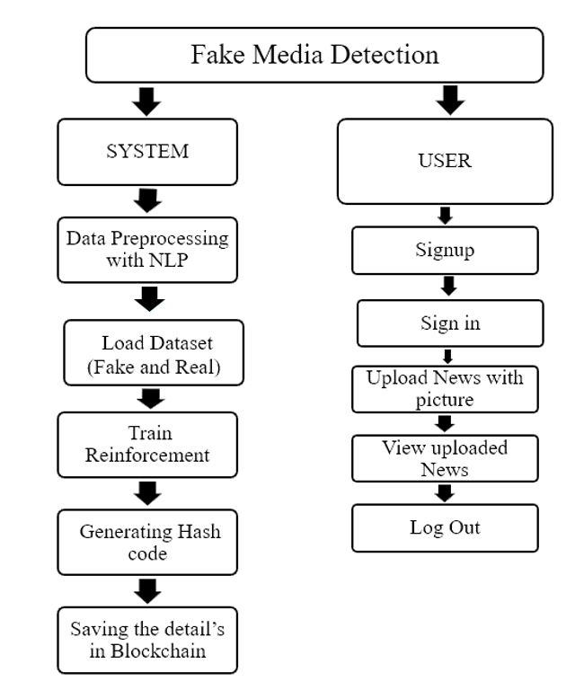
Fig 1.1 System model
As shown in Fig 1.1 A fake media detection diagram is divided into two Modules: the System Module and the User Modules. The system uses advanced tools like image recognition and machine learning to analyze media content for signs of misinformation. The user interacts with the system, submitting media for analysis or receiving results to verify the authenticity of content. Together, they work to combat the spread of fake media online.

System Modules:
Data Preprocessing Module: Utilizes NLTK techniques for text preprocessing. Removes stop words, special symbols, normalizes data, performs stemming, and lemmatization. Converts words into numeric vectors for input to the Reinforcement Learning algorithm.
Dataset Loading Module: Facilitates the loading of datasets for training and evaluation purposes. Provides graphical representations of dataset statistics (e.g., count of fake and real news).
Reinforcement Learning Module: Trains the model to detect fake news based on the processed data. Uses a reinforcement algorithm to match similarity between old and current news. Determines whether news is fake or real and rewards/punishes users accordingly.
Training and Evaluation Module: Trains the reinforcement learning model with existing datasets. Evaluates the model using metrics like RMSE (Root Mean Squared Error), MAE (Mean Absolute Error), rewards, and penalties.
Blockchain Integration Module: Manages the storage and retrieval of news data using blockchain technology. Implements smart contracts for storing user and news details securely in the blockchain. Deploys contracts and interacts with them to store and read data. Generate hash codes for the data that need to be stored in blockchain.
User Modules:
Signup and Login Module: Enables users to create accounts and log in securely. Authenticates user identity for accessing system features.
News Submission Module: Allows users to submit news articles for validation. Provides a platform to upload news content and associated images for verification.
News Verification and Viewing Module: Allows users to view the authenticity status of their submitted news. Displays a list of published news along with their classifications (fake or real).
Interaction with Smart Contracts Module: Allows users to interact with the blockchain for storing and retrieving news data securely.

Feedback and Improvement Module: Provides a mechanism for users to provide feedback on the accuracy of news classifications. Incorporates user feedback to enhance the system's performance and accuracy over time.

1.6 ORGANISATION OF THE THESIS:
Chapter 1: Introduces the project, literature review, motivation and project objective.
Chapter 2: Describes existing technology with limitations.
Chapter 3: Describes proposed solution.
Chapter 4: Gives the software requirement details for the project.
Chapter 5: Presents the results and discussions.
Chapter 6: Gives the project conclusion and future scope.

CHAPTER 2

EXISTING WORK

METHODOLOGY:
The existing system utilizes a novel database to create a decision model based on the SVM classification technique. The proposed model will be used detect the news as fake or real. with help of Reinforcement Learning.

DATA GATHERING AND PRE-PROCESSING:

Generally, reviews or comments from different sections are collected, fake or real. Most researchers can gather the data from online sites. After the gathering phase, we will upload the input comment data and verify the feasibility of the news dataset when the dataset will explore. Before classifying the comments and reviews, the following steps are applied to datasets: i. Data cleaning ii. Stemming.

2.2.1 DATA CLEANING:

Data cleaning involves removing noise and irrelevant information from text data, such as special characters, punctuation marks, and stop words like "and" and "the." For instance, removing punctuation turns "It's raining!" into "Its raining" and lowering the case makes "The" and "the" identical. Additionally, spell checking ensures accuracy, correcting errors like "helo" to "hello," while handling contractions and abbreviations maintains consistency, transforming "can't" to "cannot" and "U.S." to "United States." These steps simplify the text and improve the quality of analysis by making the data more uniform and easier to process.

2.2.2 DATA STEMMING:

Data stemming reduces words to their base form, or stem, by removing prefixes and suffixes. For example, "running," "ran," and "runs" are all stemmed to "run." Similarly, "better," "best," and "good" are all stemmed to "good." This process reduces data complexity and groups together words with similar meanings, making analysis more efficient. By standardizing word forms, stemming helps machine learning models focus on the underlying meaning of the text rather than individual variations in word usage

2.3 SUPPORT VECTOR MACHINE (SVM) CLASSIFICATION:

2.3.1 ABOUT SVM:

Support Vector Machine (SVM) is a powerful supervised machine learning algorithm that is widely used for classification and regression tasks. It is particularly effective in scenarios where the data is high-dimensional and non-linearly separable. SVM works by transforming the input data into a higher-dimensional feature space, where it attempts to find the optimal hyperplane that best separates the data points of different classes. This hyperplane is positioned in such a way that it maximizes the margin, which is the distance between the hyperplane and the nearest data points (known as support vectors) of different classes. By maximizing the margin, SVM aims to achieve better generalization and reduce overfitting, thus making it robust to noisy data and outliers. Additionally, SVM can handle both linear and non-linear classification tasks through the use of different kernel functions, such as linear, polynomial, and radial basis function (RBF) kernels, allowing it to capture complex relationships within the data. Overall, SVM is a versatile and effective algorithm for various classification tasks, including fake news detection, where it can accurately classify news articles into different categories based on their features.

2.3.2 STRENGTHS:

One of the key strengths of SVM is its ability to handle high-dimensional data effectively, making it suitable for tasks with complex decision boundaries. Additionally, SVM can employ different kernel functions (like linear, polynomial, radial basis function) to handle non-linear data by transforming it into higher dimensions, allowing for more accurate classification. However, SVM's performance might be sensitive to the choice of the kernel and the regularization parameter, and it can be computationally intensive, especially with large datasets. Despite these considerations, SVM remains widely used in various fields such as image classification, text categorization, bioinformatics, and more, owing to its robustness and effectiveness in handling diverse data types and tasks.

2.3.3 KEY CONCEPTS:

Hyperplane: In an SVM, the goal is to find a hyperplane (a line in 2D, a plane in 3D, or a higher-dimensional decision boundary) that separates different classes in the data. This hyperplane should maximize the margin between classes.

Margin: The margin is the distance between the hyperplane and the closest data points from each class. The aim is to maximize this margin to improve the model's generalization and robustness.

Support Vectors: These are the data points closest to the hyperplane and play a crucial role in determining its position and orientation. Only these points influence the hyperplane's placement.

Kernel Functions: SVM can handle non-linearly separable data using kernel functions. A kernel function transforms the original data into a higher-dimensional space where it becomes linearly separable. Common kernel functions include linear, polynomial, radial basis function (RBF), and sigmoid.

C Parameter: The regularization parameter C controls the trade-off between achieving a larger margin and minimizing classification errors. A higher C value may lead to a model that is more sensitive to the training data, potentially resulting in overfitting.

SVM for Regression: SVM can also be used for regression tasks (called Support Vector Regression, or SVR). In SVR, the model aims to fit a hyperplane that is within a specified distance (epsilon) from the actual data points.

2.4. LIMITATIONS:

The existing system for detecting and preventing fake news on social media platforms faces several limitations. Traditional algorithms often struggle with the dynamic nature of fake news, lacking adaptability to evolving tactics. They may also falter in accurately discerning subtle nuances between genuine and misleading content. Moreover, centralized data storage systems are susceptible to tampering, compromising data integrity. These drawbacks underscore the need for more sophisticated and adaptable solutions to effectively combat the proliferation of fake news.

2.5 DISADVANTAGES:

Algorithmic Rigidity: Traditional methods lack adaptability to evolving fake news tactics, struggling to keep pace with emerging misinformation strategies.

Centralized Vulnerability: Centralized data storage systems are prone to tampering, risking data integrity and authenticity of stored information.

Limited Scalability: Conventional systems might struggle to efficiently handle the massive influx of data on social media platforms.

Slow Adaptation: Sluggish adaptation to changing trends and tactics in disseminating fake news undermines timely detection and prevention efforts.

CHAPTER 3

PROPOSED SYSTEM

3.1 METHODOLOGY:
The proposed model effectively utilizes a dataset sourced from Kaggle and employs Natural Language Processing to preprocess the data. It efficiently detects the originality of news, whether it is fake or real, with the help of Reinforcement learning, ensuring high accuracy. Moreover, the user data and news are securely stored in Blockchain, ensuring transparency and security.

3.2 DATA PREPROCCESSING:
Data preprocessing is a crucial component in preparing the textual data for analysis and ensuring the effectiveness of the machine learning models. Collecting a labeled dataset containing examples of fake and real news articles is the first step, which is sourced from Kaggle datasets.
The collected text data then undergoes several preprocessing steps, including removing noise such as special characters, punctuation marks, and HTML tags. Converting text to lowercase ensures consistency, while removing stop words reduces dimensionality. Additionally, spell checking, contractions and abbreviation handling further improve the quality of the data.
Following that, the text data is tokenized and transformed into numerical vectors using techniques like TF-IDF or word embeddings like Word2Vec or GloVe. These numerical representations capture the semantic meaning of words and phrases in the text, enabling machine learning models to process the data effectively.

3.2.1 NATURAL LANGUAGE PROCCESSING:
In the fake news detection project leveraging NLP, the technology is implemented to extract meaningful features from textual data, enabling the system to identify linguistic patterns indicative of fake news. Initially, the collected textual data undergoes preprocessing, including cleaning, tokenization, and transformation into numerical representations using techniques such as TF-IDF or word embeddings. These numerical vectors capture semantic meaning, allowing the system to analyze and understand the content of news articles. NLP techniques such as sentiment analysis, named entity recognition, and topic modeling may be employed to extract additional features that can aid in fake news detection. Sentiment analysis helps determine the tone and sentiment expressed in the text, while named entity recognition identifies and categorizes entities mentioned in the news articles. Additionally, stemming and lemmatization techniques are applied to normalize words by
reducing them to their root forms, further enhancing the system's ability to identify linguistic patterns and distinguish between genuine and misleading information.

3.3 REINFORCEMENT LEARNING:
Reinforcement Learning (RL) is a branch of machine learning where an agent learns to make decisions by interacting with an environment. Unlike supervised learning, where data is labeled, or unsupervised learning, where patterns are inferred from unlabeled data, RL uses a trial-and-error approach. In RL, the agent takes actions in an environment and receives feedback in the form of rewards or penalties based on these actions. Its objective is to learn a strategy or policy that maximizes the cumulative reward over time. The agent learns through exploration and exploitation. During exploration, it tries various actions to understand the environment better. Exploitation involves using the learned knowledge to make decisions that are likely to yield higher rewards.
Key components of RL include the agent, environment, actions, rewards, and policies (strategies). Algorithms like Q-Learning, Deep Q Networks (DQN), and Policy Gradient methods, among others, are used to train RL agents. RL finds applications in various domains, such as robotics, gaming, finance, healthcare, and more. It's used for tasks like autonomous driving, game playing (e.g., AlphaGo), resource management, and personalized recommendation systems. Despite its promise, RL faces challenges like sample inefficiency, exploration-exploitation trade-offs, and handling continuous and high-dimensional state spaces. Ongoing research aims to address these challenges for broader and more effective applications of RL.
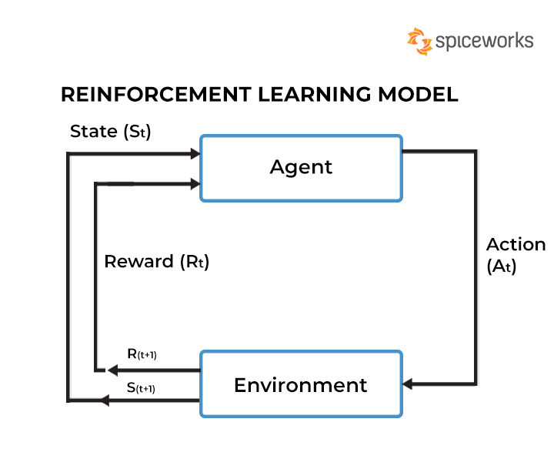
Fig. 3.1. Reinforcement Learning.
In detecting the fake news, as shown in Fig 3.1 the system operates as an agent within the environment of social media networks or online platforms where news articles are shared. Each news article represents a state (St) that the agent analyzes to determine its authenticity. The agent takes actions (At) by applying natural language processing (NLP) techniques to classify the news articles as either fake or real, aiming to accurately identify misinformation. After classifying a news article, the agent receives feedback in the form of a reward or punishment (R) based on the accuracy of its classification. Correct classifications result in rewards, indicating a positive contribution to combating fake news, while incorrect classifications lead to punishments, signaling potential errors that need correction. This feedback loop enables the agent to learn from its experiences and refine its classification strategies over time, aligning with the principles of reinforcement learning.
Here the agent's actions involve preprocessing textual data, extracting features using NLP techniques, and training machine learning models to classify news articles. By receiving feedback from the environment in the form of rewards and punishments, the agent learns to make better decisions and improve the accuracy of fake news detection. The integration of reinforcement learning principles allows the system to adapt and optimize its strategies for identifying fake news, contributing to a more effective and reliable detection mechanism in combating misinformation on social media platforms.

3.3 RANDOM FOREST:
A random forest is a machine learning technique that’s used to solve regression and classification problems. It utilizes ensemble learning, which is a technique that combines many classifiers to provide solutions to complex problems.
Random Forest is a powerful machine learning technique used for solving both regression and classification problems. It leverages ensemble learning, a method that combines multiple decision trees to provide solutions to complex tasks. A Random Forest algorithm comprises numerous decision trees, forming a 'forest' that is trained through bagging or bootstrap aggregating. Bagging is an ensemble meta-algorithm that enhances the accuracy of machine learning models by training multiple models on different subsets of the dataset and then combining their predictions. In the case of Random Forest, the algorithm establishes the final prediction based on the aggregated predictions of the individual decision trees. It does so by taking the average or mean of the output from various trees. Increasing the number of trees in the forest generally improves the precision of the outcome, making Random Forest an effective and versatile tool for a wide range of tasks.
Random Forest addresses the limitations of decision tree algorithms by reducing overfitting and increasing precision. It achieves this by generating predictions without requiring extensive configurations, making it easier to implement compared to other algorithms. Additionally, Random Forest provides several advantages over decision trees, including higher accuracy, effective handling of missing data, and the ability to produce reasonable predictions without hyper-parameter tuning. In every Random Forest tree, a subset of features is randomly selected at each node's splitting point, further enhancing its predictive power and robustness. Thus, Random Forest serves as a powerful tool for solving complex problems in machine learning, offering improved accuracy and performance compared to individual decision trees.

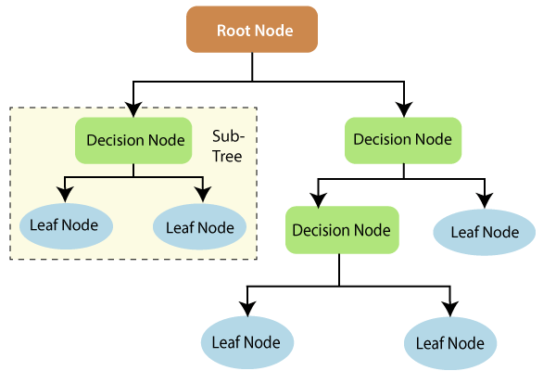
Fig. 3.2. Decision Tree diagram

The information theory shown in Fig. 3.2. Decision Tree diagram provide more information on how decision trees work. A decision tree diagram consists of three main parts: the root node, decision nodes, and leaf nodes. The root node kicks off the process, presenting the initial decision or condition. Decision nodes follow, representing choices or conditions based on prior decisions. Finally, leaf nodes mark the end points, indicating the ultimate outcomes or classifications resulting from the decision process.

3.5 BLOCKCHAIN:
In the fake news detection project, leveraging blockchain technology to store user details and news information enhances security, transparency, and data integrity. Each user's details, including authentication credentials and activity logs, can be stored as transactions on the blockchain network. These transactions are cryptographically secured and immutable, ensuring that user data remains tamper-proof and resistant to unauthorized modifications. By storing user details on the blockchain, the system provides a transparent and auditable record of user interactions, enhancing accountability and trust.
Similarly, news details, such as article content, timestamps, and classification results, can also be stored on the blockchain. Each news article can be represented as a transaction, with its
content and metadata securely recorded on the blockchain ledger. This ensures the integrity and authenticity of news information, preventing tampering or manipulation of news articles after publication. Additionally, blockchain technology enables transparent verification of news sources and content authenticity, empowering users to verify the credibility of news articles independently.
By leveraging blockchain for storing user and news details, the fake news detection system enhances security, transparency, and trust in the platform. Users can be confident that their personal information is securely stored and protected from unauthorized access, while the integrity of news information is preserved, promoting accountability and combating misinformation effectively. Furthermore, the decentralized nature of blockchain ensures that no single entity has control over the stored data, fostering a decentralized and censorship-resistant platform for combating fake news on social media networks.

3.6 COMBINED APPROACH:
i. Data Verification: Use blockchain to store and verify the origin and history of media. This can help establish the authenticity of the content and provide traceability.
ii. Model Training: Train NLP and reinforcement learning models using labeled data from blockchain-verified sources to improve their ability to detect fake media.
iii. Automated Detection: Implement smart contracts on the blockchain that use NLP and RL models to automatically analyze incoming content and flag potential fake media.
iv. Community Involvement: Encourage community involvement by incentivizing users to participate in the detection process and report suspicious content using blockchain-based rewards.
This combined approach leverages the strengths of each technology to create a robust system for detecting fake media. It can help maintain the integrity of information in digital media and prevent the spread of misinformation.
\

CHAPTER 4

HARDWARE AND SOFTWARE REQUIREMENTS

4.1. HARDWARE REQUIREMENTS:
Processor - I7/Intel Processor
Hard Disk - 160GB
Key Board - Standard Windows Keyboard
Mouse - Two or Three Button Mouse
Monitor - SVGA
RAM - 8GB

4.2. SOFTWARE REQUIREMENTS:
Operating System : Windows 11
Programming Language : Python
IDE/Workbench : PyCharm
Technology : Python 3.6+

4.3. FRAMEWORK:
Django is a high-level Python web framework that encourages rapid development and clean, pragmatic design. It simplifies the process of building web applications and follows the "don't repeat yourself" (DRY) principle, which helps developers avoid writing redundant code. Django is popular for its ease of use and comprehensive set of features.
Here are some key features of Django:
1. Model-View-Controller (MVC) Architecture: Django follows the MVC pattern, but refers to it as Model-View-Template (MVT). Models define the database structure, views handle the business logic, and templates manage the presentation layer.
2. ORM (Object-Relational Mapping): Django's ORM allows developers to interact with the database using Python objects instead of raw SQL queries.
3. URL Routing: Django provides a flexible and powerful URL routing system that maps URL paths to views.
4. Forms: Django simplifies handling user input with its form classes, which provide validation, rendering, and data conversion.
5. Admin Interface: Django includes a built-in admin interface that allows for easy management of models and data.
6. Security: Django provides built-in security features such as cross-site scripting (XSS) protection and SQL injection prevention.
7. Scalability and Reusability: Django's design encourages the use of reusable apps, making it easy to scale projects and add functionality.
Django's comprehensive documentation and strong community support make it an excellent choice for building web applications with Python.

4.4. MODULES:
System Modules:
- Data Preprocessing Module:
Utilizes NLTK techniques for text preprocessing.
Removes stop words, special symbols, normalizes data, performs stemming, and lemmatization.
Converts words into numeric vectors for input to the Reinforcement Learning algorithm.
- Reinforcement Learning Module:
Trains the model to detect fake news based on the processed data.
Uses a reinforcement algorithm to match similarity between old and current news.
Determines whether news is fake or real and rewards/punishes users accordingly.
- Blockchain Integration Module:
Manages the storage of user data and retrieval of news data using blockchain technology.
Activating blockchain with Ethereum involves deploying smart contracts using tools like Truffle, which streamlines the process of compiling and migrating contracts to a local network. Truffle simplifies the deployment process, enabling developers to seamlessly interact with Ethereum-based smart contracts on their local development environment.
- IPFS Integration Module:
Handles the storing of application images on IPFS (InterPlanetary File System) for accessibility.
- User Interface Module:
Provides a user-friendly interface for users to interact with the system.
Displays functionalities like signup, login, uploading news, viewing published news, and testing news authenticity.
- Training and Evaluation Module:
Trains the reinforcement learning model with existing datasets.
Evaluates the model using metrics like RMSE (Root Mean Squared Error), MAE (Mean Absolute Error), rewards, and penalties.
- News Publishing Module:
Allows users to submit news for analysis.
Classifies submitted news as fake or real using the trained model.
Stores validated news in the blockchain for transparency and security.

USER MODULES:
- Signup and Login Module:
Enables users to create accounts and log in securely.
Authenticates user identity for accessing system features.
- Dataset Loading Module:
Facilitates the loading of datasets for training and evaluation purposes.
Provides graphical representations of dataset statistics (e.g., count of fake and real news).
- News Submission Module:
Allows users to submit news articles for validation.
Provides a platform to upload news content and associated images for verification.
- News Verification and Viewing Module:
Allows users to view the authenticity status of their submitted news.
Displays a list of published news along with their classifications (fake or real).
- Interaction with Smart Contracts Module:
Allows users to interact with the blockchain for storing and retrieving news data securely.
- Feedback and Improvement Module:
Provides a mechanism for users to provide feedback on the accuracy of news classifications.
Incorporates user feedback to enhance the system's performance and accuracy over time.

CHAPTER 5

RESULTS & DISCUSSIONS

5.1. NUMERICAL METHODS TO CALCULATE ERROR:

5.1.1. RMSE:

Root Mean Square Error (RMSE) is a statistical measure used to evaluate the accuracy of a model's predictions by quantifying the difference between predicted values and actual observed values. It is widely used in regression analysis, forecasting, and machine learning to assess model performance.

RMSE is calculated as follows:

1. Compute the square of the difference between each predicted value and its corresponding actual value.

2. Calculate the average of these squared differences.

3. Take the square root of the average to obtain RMSE.

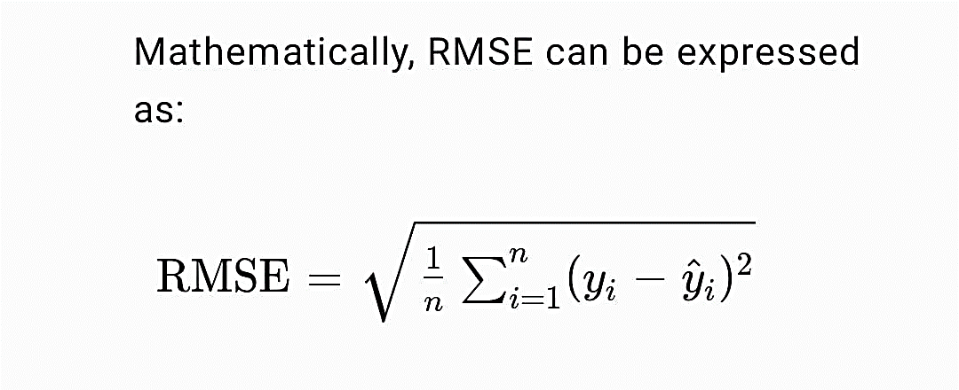- - - - - - - - - - - - (eq 5.1.1)

Where:

- n is the number of data points.

- y is the actual observed value.

- $\hat{y}$ is the predicted value.

RMSE provides an absolute measure of the model's prediction error, with a lower RMSE indicating a better fit. It is sensitive to large errors because the squared differences exaggerate their impact, making RMSE particularly useful when outliers are present.

In practice, RMSE is often used alongside other metrics like Mean Absolute Error (MAE) and R-squared to provide a comprehensive evaluation of a model's performance. By quantifying prediction errors, RMSE helps in comparing models and guiding improvements in model accuracy

5.1.2 MAE:

Mean Absolute Error (MAE) is a statistical measure used to evaluate the accuracy of a model's predictions by quantifying the absolute difference between predicted values and actual observed values. It is a widely used metric in regression analysis, forecasting, and machine learning to assess model performance.

MAE is calculated as follows:

1. Calculate the absolute difference between each predicted value and its corresponding actual value.

2. Compute the average of these absolute differences to obtain MAE.

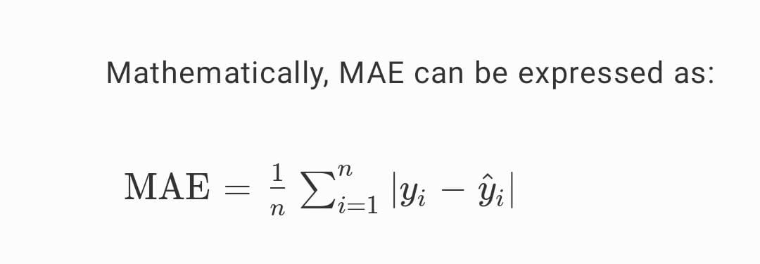 - - - - - - - - - - - - (eq 5.1.2)

Where:

- n is the number of data points.

- y is the actual observed value.

-$\hat{y}$ is the predicted value.

MAE provides a measure of prediction error in the same units as the data, which makes it easy to interpret. A lower MAE indicates a better fit, as it means the model's predictions are closer to the actual values.

Unlike RMSE, which is sensitive to outliers due to the squared differences, MAE gives equal weight to all errors, making it a robust metric in the presence of outliers. By quantifying prediction errors, MAE helps in comparing models and guiding improvements in model accuracy.

5.2. SCREENSHOTS:

Fig. 5.2.1. New User Signup
In above Fig. 5.2.1. New User Signup click on ‘New User Signup Here’ link to get below signup screen.


Fig. 5.2.2. Signup Details
In above Fig. 5.2.2 Signup Details user is entering signup details and then click on ‘Submit’ button to get below output.


Fig. 5.2.3. Succeed of Signup
In above Fig. 5.2.3. Succeed of Signup in red colour text we can see user details saved in Blockchain and now click on ‘User Login Here’ to get below login screen.


Fig. 5.2.4. User Login
In above Fig. 5.2.4. User Login user is login and after login will get below screen


Fig. 5.2.5. Welcome Screen
In above Fig. 5.2.5. Welcome Screen user can click on ‘Load Buzz Feed Dataset’ button to load dataset and get below output.

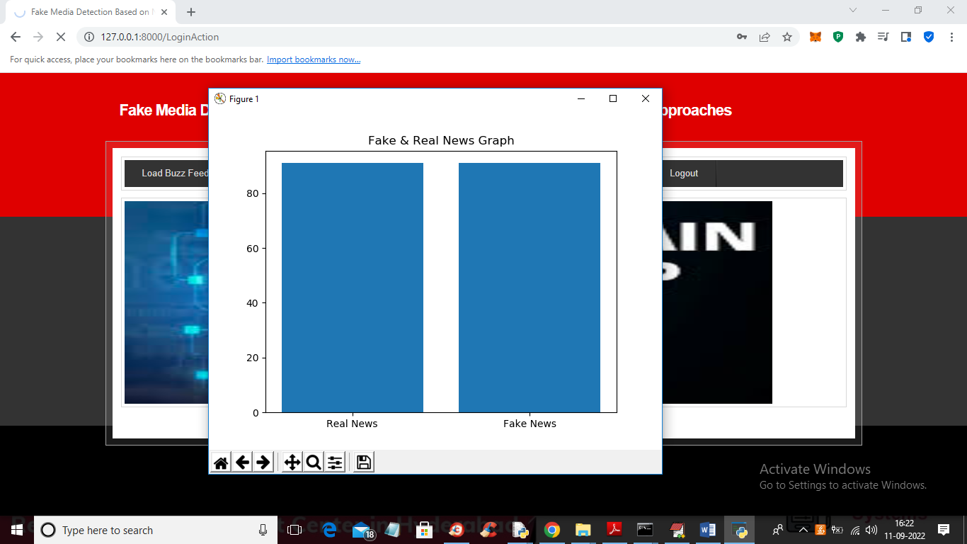
Fig. 5.2.6. Fake & Real News Graph
In above Fig. 5.2.6. Fake & Real News Graph dataset loaded and we can see number of Fake and Real NEWS graph and in above graph x-axis represents NEWS TYPE and y-axis contains count of that news type and now close above graph to get below output.

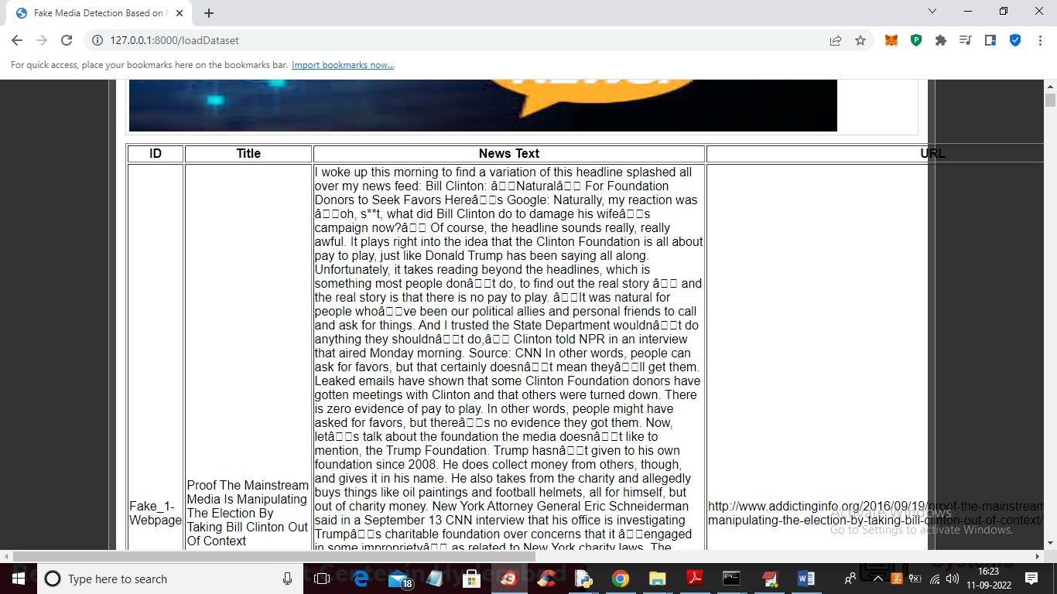
Fig. 5.2.7. Load Buzz Feed Datasets
In above Fig. 5.2.7. Load Buzz Feed Datasets we can see News loaded from dataset and now click on ‘Train Reinforcement Learning’ link to train Reinforcement algorithm and get below output.

Fig. 5.2.8. RMSE AND MAE
In above Fig. 5.2.8. RMSE AND MAE values can be seen. RMSE and MAE are metrics used to assess the accuracy of predictive models, especially in regression analysis.


Fig. 5.2.9. Output

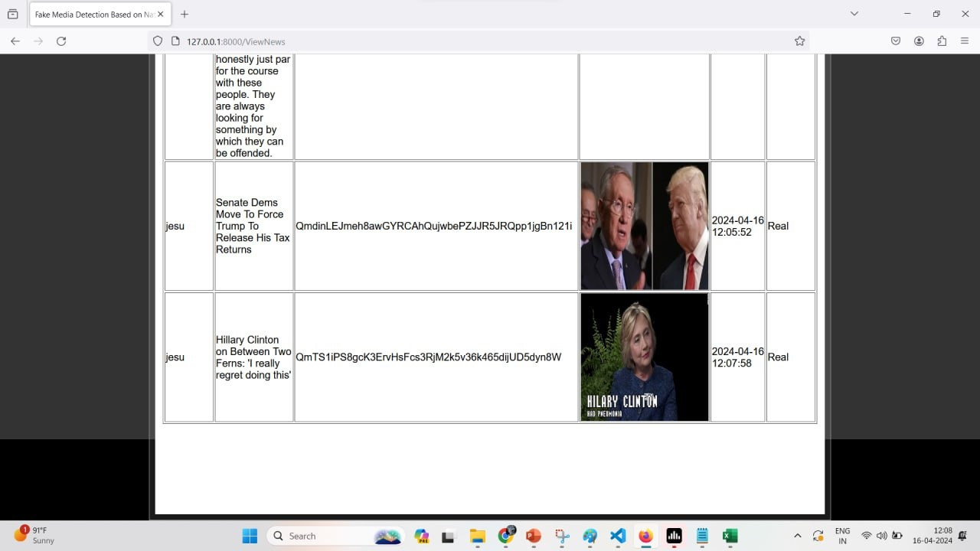
Fig. 5.2.10. Output

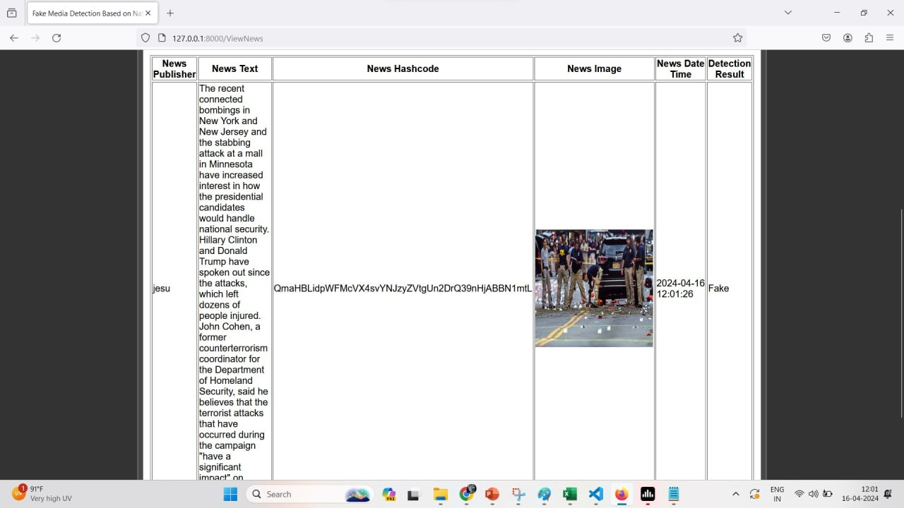
Fig. 5.2.11. Output
Any number of images and news can be uploaded and verified for real or fake.

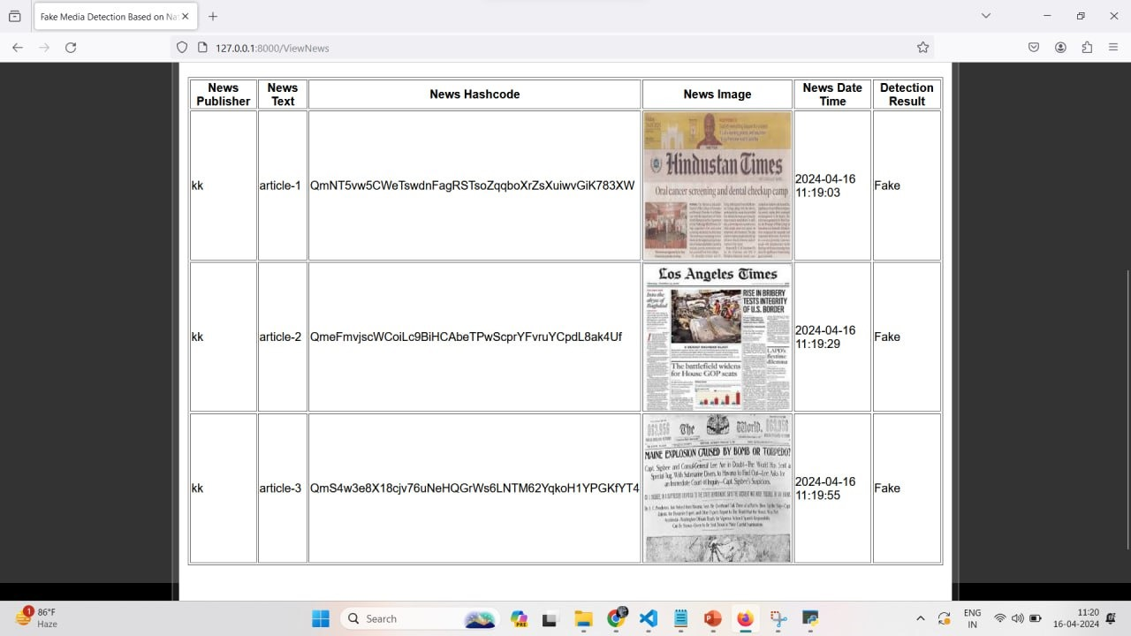
Fig. 5.2.12. Output

CHAPTER 6

CONCLUSION & FUTURE SCOPE

CONCLUSION:

The proposed fusion of Reinforcement Deep Learning and Blockchain technology presents a compelling solution to combat the proliferation of fake news in social media. Reinforcement learning involves training models to make decisions through trial and error, receiving feedback in the form of rewards or penalties. This can be useful in detecting fake media as the model can continuously learn and adapt to new types of fakes over time. The model can be rewarded for correctly identifying fake media and penalized for false positives or false negatives. This way, the model learns to distinguish between real and fake media more effectively. Blockchain's immutability ensures that once data (such as the identity of media and its verification status) is recorded on the blockchain, it cannot be altered. This creates a trusted record of media authenticity. Blockchain can enable decentralized verification processes, where multiple validators independently assess the authenticity of media. This can improve the reliability and trustworthiness of the detection process. Blockchain can track the provenance of media, helping to identify its source and history. This can assist in verifying whether media has been tampered with or is genuine. By leveraging Reinforcement algorithms for similarity matching and incentivizing genuine news sources through Blockchain-driven rewards, this innovative approach ensures data integrity while penalizing the spread of falsities.

By integrating RL with blockchain, a system can be created that not only adapts to new types of fake media but also ensures a secure and transparent record of the detection process. The RL model can learn from data and adapt its detection strategies, while blockchain can provide a secure and trusted record of the media's authenticity and verification history. Together, these technologies can improve the accuracy and reliability of fake media detection systems, providing a robust solution to combat the growing problem of fake media. Integrating NLTK techniques for data preprocessing and employing smart contracts for decentralized storage enhances the system's robustness. Evaluation against conventional methods showcases its superior performance, underscoring its potential in tackling the persistent challenge of fake news dissemination. This pioneering amalgamation of AI and Blockchain holds promise in fortifying social media platforms against misinformation.

FUTURE ENHANCEMENT:

The combination of reinforcement learning (RL) and blockchain technology presents significant potential for advancing fake media detection in the future. RL can be used to develop sophisticated models that continuously learn and adapt to emerging forms of fake media, such as deepfakes and manipulated content. These models can operate in real-time, allowing for rapid identification and flagging of fake media across multiple platforms. Blockchain's immutable ledger and secure provenance tracking provide a trusted and transparent record of media authenticity, helping to verify content sources and detect tampering.

Together, RL and blockchain can create a collaborative ecosystem for decentralized media verification. Independent validators can assess content authenticity, while RL models improve detection accuracy over time through shared learning. Blockchain's incentivization and reputation systems can encourage user participation in detection efforts, while penalizing malicious actors.

The integration of these technologies can lead to trustworthy AI systems capable of dynamic defense against fake media threats. These systems will enhance cross-platform coordination, allowing for seamless identification and management of fake content. As a result, the future of RL and blockchain for fake media detection holds promise for creating a more secure and reliable digital environment. Future enhancements for this proposed system could involve refining the reinforcement learning algorithms to adapt in real-time to evolving tactics used in spreading fake news. Additionally, integrating more extensive datasets encompassing varied languages and cultural contexts could enhance the model's accuracy and robustness. Exploring advanced NLP techniques like transformer models could further improve the system's ability to detect nuanced fake news content. Moreover, enhancing the scalability and efficiency of the Blockchain infrastructure and smart contracts to handle larger volumes of data while maintaining decentralization would be a crucial aspect for future development.

REFERENCES:

[1] D. W. Otter, J. R. Medina, and J. K. Kalita, ‘‘A survey of the usages of deep learning for natural language processing,’’ IEEE Trans. Neural Netw. Learn. Syst., vol. 32, no. 2, pp. 604–624, Feb. 2021.

[2] S. R. Sahoo and B. B. Gupta, ‘‘Multiple features based approach for automatic fake news detection on social networks using deep learning,’’ Appl. Soft Comput., vol. 100, Mar. 2021.

[3] N. Aslam, I. Ullah Khan, F. S. Alotaibi, L. A. Aldaej, and A. K. Aldubaikil, ‘‘Fake detect: A deep learning ensemble model for fake news detection,’’ Complexity, vol. 2021, Apr. 2021.

[4] S. A. Althubiti, F. Alenezi and R. F. Mansour, "Natural language processing with optimal deep learning based fake news classification," Computers, Materials & Continua, vol. 73, no.2, pp. 3529–3544, 2022.

[5] A. H. J. Almarashy, M. -R. Feizi-Derakhshi and P. Salehpour, "Enhancing Fake News Detection by Multi-Feature Classification," in IEEE Access, vol. 11, pp. 139601-139613, 2023.

